


STUDENT NAME: ________________________ YEAR:_____ INTENDED START DATE___/___ /____
Parent/Carer Checklist | Parent/Carer  Tick & Initial
BIRTH CERTIFICATE / PASSPORT supplied to school and copy made for student file  Website: www.qld.gov.au/birthcertificate | ☐
I have completed and signed the APPLICATION FOR STUDENT ENROLMENT FORM | ☐
I have completed and signed the STUDENT RESOURCE SCHEME – PARTICIPATION AGREEMENT FROM | ☐
I have completed and signed the STATE SCHOOL CONSENT FORM and indicated what name to be used and filled in all the boxes with information. | ☐
I have completed and signed the INTERNET / COMPUTER AGREEMENT | ☐
I have completed SCHOOL CLASS PHOTOS PERMISSION | ☐
I have completed and signed the ONLINE SERVICE CONSENT FORM | ☐
I have completed the SUBJECT SELECTION FORM (Years 7 to 12)  Website: https://kurandadistrictsc.eq.edu.au | ☐
I understand school fees, camps, excursions, incursions, etc will be invoiced and directly emailed to the nominated financially responsible account holder/s. I understand I am to pay through the BPOINT web-link located at the bottom left hand corner of the invoice.
A payment plan/s can be arranged through Account Receivable at request only.

Parent Signature: ______________________________ Date: ____/____/_____

I have a copy of the STUDENT ABSENCES (SAME DAY NOTIFICATION) information and am aware of what needs to happen and will happen if my child/ren is away. | ☐
I have a copy of the GOOD STANDING POLICY and have read, understood and am aware of what needs to happen and will happen if my child is away. | ☐
I have purchased my child’s SCHOOL UNIFORM | ☐
I have a copy of the TUCKSHOP MENU | ☐

Application for student enrolment form

INSTRUCTIONS
Please refer to the Application to enrol in a Queensland state school information sheet at the end of this form when completing this application. Completion and submission of this application form to the school does not confirm enrolment. The school will notify you of the outcome of your application as soon as practicable.

Failure or refusal to complete those sections of the form marked with an (*) or to provide required documentation may result in a refusal to process your application. These questions and your consent are considered necessary to ensure the school can undertake its administrative and care responsibilities.

Sections of the form not marked (*) are optional. However, failure to complete these sections may result in the school not being eligible for important Federal and State Government funding reliant on such information. Parents of all students in Australia have been asked to provide information on their family background as part of a national initiative towards providing an education system that is fair to all students, regardless of their background. The required information includes the Indigenous status and language background of the student, and the education, occupation and language background of the parents.

If you have any questions about the enrolment form or process, or require assistance completing this form, including translation services, please contact the school in the first instance.
PRIVACY STATEMENT
The Department of Education (DoE) is collecting the information on this form for the purposes outlined in the Education (General Provisions) Act 2006 (Qld) (EGPA 2006), and in particular for:
- assessing whether your application for enrolment should be approved
- meeting reporting obligations required by law or under Federal – State Government funding arrangements
- administering and planning for providing appropriate education, training and support services to students
- assisting departmental staff to maintain the good order and management of schools, and to fulfil their duty of care to all students and staff
- communicating with students and parents.

This collection is authorised by ss. 155 and 428 of the EGPA 2006. DoE will disclose personal information from this form to the Queensland Curriculum and Assessment Authority when opening student accounts, in compliance with Part 3 of the Education (Queensland Curriculum and Assessment Authority) Act 2014 (Qld).

Personal Information from this form will also be supplied to Centrelink in compliance with ss.194 and 195 of the Social Security (Administration) Act 1999 (Cth). De-identified information concerning parents’ school and non-school education, occupation group and main language other than English and students’ country of birth, main language other than English, gender and Indigenous status, is supplied to the Australian Government Department of Education in compliance with Federal – State Government funding agreements.

Personal information collected on this form may also be disclosed to third parties where authorised or required by law. Your information will be stored securely. If you wish to access or correct any of the personal information on this form or discuss how it has been dealt with, please contact the school in the first instance. If you have a concern or complaint about the way your personal information has been collected, used, stored or disclosed, please also contact the school in the first instance.

PROSPECTIVE STUDENT DEMOGRAPHIC DETAILS
Legal family name*
(as per birth certificate)
Legal given names*
(as per birth certificate)
Preferred family name |  | Preferred given names
Gender* | Male Female | Date of birth*
Copy of birth certificate available to show school staff* |     Yes No | Enrolment may not be approved without enrolling staff sighting the prospective student’s birth certificate. An alternative to birth certificate will be considered where it is not possible to obtain a birth certificate (e.g. prospective student born in country without birth registration system. Passport or visa documents will suffice). This does not include failure to register a birth or reluctance to order a birth certificate.  The requirement to sight the birth certificate does not apply where the prospective student has been previously enrolled in a state school and a birth certificate has been sighted.  For international students approved for enrolment by EQI, a passport or visa will be acceptable.
For prospective mature age students, proof of identity supplied and copied* | YES NO | Prospective mature age students must provide photographic identification which proves their identity:  - current driver’s licence; or  - adult proof of age card; or  - current passport.


Uncontrolled copy. Refer to the Department of Education Policy and Procedure Register at https://ppr.qed.qld.gov.au/pp/enrolment-in-state- primary-secondary-and-special-schools-procedure to ensure you have the most current version of this document G:\Coredata\Admin\9. KDSC Structures & Procedures\2024 Enrolment Kit



APPLICATION DETAILS
Has the prospective student ever attended a Queensland state school? | Yes No | If yes, provide name of school and approximate date of enrolment.
What year level is the prospective student seeking to enrol in? |  | Please provide the appropriate year level.
Proposed start date |  | Please provide the proposed starting date for the prospective student at this school.
 |  | If yes, | Name:
 |  | If yes, | Year Level
Does the prospective |  | provide | Year Level
student have a sibling | Yes No | name of | Year Level
attending this school or  any other Queensland |  | sibling, year  level, date of | Date of birth
state school? |  | birth, and school | Date of birth
state school? |  | birth, and school | School

INDIGENOUS STATUS
Is the prospective student of Aboriginal or Torres Strait Islander origin? | No | Aboriginal | Torres Strait Islander | Both Aboriginal and Torres Strait Islander

FAMILY DETAILS
Parents/carers | Parent/carer 1 |  |  | Parent/carer 2
Family name*
Given names*
Title | Mr. Mrs. Ms. | Miss | Dr. | Mr. Mrs. Ms. | Miss | Dr.
Gender | Male Female |  |  | Male Female
Relationship to prospective student*
Is the parent/carer an emergency contact?* | Yes No |  |  | Yes No
1st Phone contact number* | Work/home/mobile |  |  | Work/home/mobile
2nd Phone contact number* | Work/home/mobile |  |  | Work/home/mobile
3rd Phone contact number* | Work/home/mobile |  |  | Work/home/mobile
Email
Occupation
What is the occupation group of the parent/carer? | (Please select the parental occupation group from the list provided at the end of this form. If parent/carer 1 is not currently in paid work but has had a job in the last 12 months or has retired in the last 12 months, please use the last occupation. If parent/carer 1 has not been in paid work in the last 12 months, enter ‘8’) |  |  | (Please select the parental occupation group from the list provided at the end of this form. If parent/carer 2 is not currently in paid work but has had a job in the last 12 months or has retired in the last 12 months, please use the last  occupation. If parent/carer 2 has not been in paid work in the last 12 months, enter ‘8’)
Employer name
Country of birth
Does parent/carer 1 or parent/carer 2 speak a language other than English at home? (If more than one language, indicate the one that is spoken most often) | No, English only  Yes, other – please specify  Needs interpreter? Yes | No |  | No, English only  Yes, other – please specify  Needs interpreter? Yes | No
Is the parent/carer an Australian citizen? | Yes No |  |  | Yes No
Is the parent/carer a permanent resident of Australia? | Yes No |  |  | Yes No

# Refer to page 9 of 21
Page 2 of 21

FAMILY DETAILS (continued)
Parents/carers | Parent/carer 1 |  |  | Parent/carer 2
Address line 1
Address line 2
Suburb/town
State |  | Postcode |  |  | Postcode
Mailing address (if it is the same as principal place of residence, write 'AS ABOVE')
Address line 1
Address line 2
Suburb/town
State |  | Postcode |  |  | Postcode
Parent/carer school education | What is the highest year of schooling parent/carer 1 has completed? (For people who have never attended school, mark 'Year 9 or equivalent or below') |  |  | What is the highest year of schooling parent/carer 2 has completed? (For people who have never attended school, mark 'Year 9 or equivalent or below')
Year 9 or equivalent or below
Year 10 or equivalent Year 11 or equivalent Year 12 or equivalent
Parent/carer non-school education | What is the level of the highest qualification parent/carer 1 has completed? |  |  | What is the level of the highest qualification parent/carer 2 has completed?
Certificate I to IV (including trade certificate)
Advanced Diploma/Diploma

Bachelor degree or above

No non-school qualification

COUNTRY OF BIRTH*
In which country was the prospective student born? | Australia  Other (please specify country)  Date of arrival in Australia
Is the prospective student an Australian citizen? | Yes No (if no, evidence of the prospective student's immigration status to be completed)

PROSPECTIVE STUDENT LANGUAGE DETAILS
Does the prospective student speak a language | No, English only
other than English at home? | Yes, other – please specify

EVIDENCE OF PROSPECTIVE STUDENT'S IMMIGRATION STATUS (to be completed if this person is NOT an Australian citizen) *
Permanent resident | Complete passport and visa details section below
Student visa holder | Date of arrival in Australia | Date enrolment approved to:
Student visa holder | EQI receipt number:
Temporary visa holder | Complete passport and visa details section below. Temporary visa holders must obtain an 'Approval to enrol in a state school' from EQI
Other, please specify

EVIDENCE OF PROSPECTIVE STUDENT'S IMMIGRATION STATUS* (continued)
Passport and visa details (to be completed for a prospective student who is NOT an Australian citizen). NOTE: A permanent resident will have a visa grant notification with an indefinite stay period indicated.
For prospective students arriving in Australia as refugee or humanitarian entrants, either PLO 56 Immigration issued card or ‘Document to travel to Australia’ with ‘stay indefinite’ recorded must be sighted by the school.
Passport number |  | Passport expiry date
Visa number |  | Visa expiry date (if applicable)
Visa sub class

PROSPECTIVE STUDENT’S PREVIOUS EDUCATION / ACTIVITY
Where does prospective student come from? | Queensland Interstate Overseas
Previous Education/Activity | Kindergarten  Full-Time Employment | School | Full-Time Employment  VET | Other  Home Education
Please provide name and address of education provider/activity provider/employer

RELIGIOUS INSTRUCTION*
From Year 1, the prospective student may participate in religious instruction if it is available.  If you tick ‘No’ or if the nominated religion is not represented within the school’s religious instruction program, the prospective student will receive other instruction in a separate location during the period arranged for religious instruction.  Parents/carers may change these arrangements at any time by notifying the principal in writing. | Do you want the prospective student to participate in religious instruction?
No
Yes
 | If ‘Yes’, please nominate the religion:
 | # Religious Instruction is not currently offered at Kuranda District State College

PROSPECTIVE STUDENT ADDRESS DETAILS*
Principal place of residence address
Address line 1
Address line 2
Suburb/town |  | State |  | Postcode
Mailing address (if it is the same as principal place of residence, write 'AS ABOVE')
Address line 1
Address line 2
Suburb/town |  | State |  | Postcode
Email

EMERGENCY CONTACT DETAILS (Other emergency contact details if parents/carers listed previously are not emergency contacts or cannot be contacted. At least one emergency contact must be provided) *
 | Emergency contact | Emergency contact
Name
Relationship (e.g. aunt)
1st phone contact number* | Work/home/mobile | Work/home/mobile
2nd phone contact number* | Work/home/mobile | Work/home/mobile
3rd phone contact number* | Work/home/mobile | Work/home/mobile

PROSPECTIVE STUDENT MEDICAL INFORMATION (including allergies) *
Privacy Statement
The Department of Education (DoE) is collecting this medical information in order to address the medical needs of students during school
hours as well as during school excursions, school camps, sports and other school activities. DoE will not use this information to make a decision about a prospective student’s eligibility for enrolment. The information will only be used by authorised employees of the department and DoE will only record,
use and disclose the medical information in accordance with the confidentiality provisions at Section 426 of the Education (General Provisions) Act 2006.
It is essential that the school is advised before the prospective student’s first day of attendance if the prospective student has any medical conditions. The school administration staff must also be informed of any new medical conditions or a change to medical conditions as soon as they are known.
Should the prospective student need to take medication during school hours, an Individual Health Plan, including Emergency Health Plan if relevant, or Authority to Administer Medication Form will need to be completed each year and retained at the office.
No known medical conditions
Medical condition (including allergies/sensitivities), symptoms and management (please refer to the list of Medical Condition categories provided)
Medical condition (including allergies/sensitivities), symptoms and management (please refer to the list of Medical Condition categories provided)
Medical condition (including allergies/sensitivities), symptoms and management (please refer to the list of Medical Condition categories provided)
Does the prospective student require any medical aids or devices (such as glasses, contact lenses, prosthetics or orthotics)? This is for the purpose of informing planning for school activities such as sport and school excursions. | No | Yes, please specify
Name of prospective student's medical practitioner (optional) |  |  |  |  | Contact number of medical practitioner
I authorise school staff to contact the prospective student’s medical practitioner for the purposes of seeking advice in cases where an immediate but non-life threatening response is required (for instance, when the prospective student may be on an excursion or sporting event)? (answer only if medical practitioner details have been provided above) |  |  |  |  |  | Yes | No
Medicare card number  (optional) |  |  |  |  | Position Number
Card Colour | Green |  | Yellow | Blue | Expiry Date | / /
Cardholder name (if not in name of prospective student)
Private health insurance company name (if covered) (optional) |  |  |  |  | Private health insurance membership number (leave blank if company name is not provided)
# refer to page 8 of 21
COURT ORDERS*
Out-of-Home Care Arrangements*
Under the Child Protection Act 1999, when a Child Protection Order is approved by the Children’s Court, the child is placed in out-of-home care (OOHC). Out-of-home care includes short- or long-term placement with an approved kinship or foster carer; in a supported independent living arrangement; in a safe house; and in residential care.
Is the prospective student identified as residing in out-of-home care? | Yes No
If yes, what are the dates of the court order? Please provide a copy of the court order and/or the Authority to Care. | Commencement date
 | End date
Contact details of the Child Safety Officer (if known) | Name
Contact details of the Child Safety Officer (if known) | Phone number

 | COURT ORDERS* (continued)
 | Family Court Orders*
 | Are there any current orders made pursuant to the Family Law Act 1975 concerning the welfare, safety or parenting arrangements of the prospective student? |  |  |  |  |  |  |  |  |  |  |  | Yes No
 | If yes, what are the dates of the court order? Please provide a copy of the court order. |  |  |  |  |  |  |  |  |  |  |  | Commencement date
 |  |  |  |  |  |  |  |  |  |  |  |  | End date
 | Other Court Orders*
 | Are there any other current court orders, such as a domestic violence order, concerning the welfare, safety or parenting arrangements of the prospective student? |  |  |  |  |  |  |  |  |  |  |  | Yes No
 | If yes, what are the dates of the court order? Please provide a copy of the court order. |  |  |  |  |  |  |  |  |  |  |  | Commencement date
 |  |  |  |  |  |  |  |  |  |  |  |  | End date
TRAVEL DETAILS
Mode of transport to school |  |  |  | Walk Car Bus Bicycle  Other
BUS ROUTE
Which bus is your student travelling on? |  |  |  | Koah Kowrowa Mantaka Speewah Top of the Range  Town Bus
APPLICATION TO ENROL*
I hereby apply to enrol my child or myself at _.

I understand that supplying false or incorrect information on this form may lead to the reversal of a decision to approve enrolment. I believe that the information. I have supplied on this form is true and correct in every particular, to the best of my knowledge.
 |  |  |  |  |  | Parent/carer 1 |  |  |  |  | Parent/carer 2 |  |  |  |  | Prospective student
Signature
Date |  |  |  |  |  | / / |  |  |  |  | / / |  |  |  |  | / /
 | Office use only
 | Enrolment decision |  |  |  |  |  | Has the prospective student been accepted for enrolment? Yes No (applicant advised in writing)  If no, indicate reason:  Does not meet School EMP or Enrolment Eligibility Plan requirements Prospective student is mature age and school is not a mature age state school Does not meet Prep age eligibility requirement  Prospective student is subject to suspension from a state school at the time of enrolment application Does not meet requirements for enrolment in a state special school  Does not have an approved flexible arrangement with the school  School does not offer year level prospective student is seeking to be enrolled in Prospective student has no remaining semester allocation of state education
 | Date enrolment processed |  |  |  |  |  | Year level |  |  | Roll Class |  |  |  | EQ ID
 | Independent student |  | Yes No |  |  |  |  |  |  | Birth certificate/passport sighted, number recorded and DOB confirmed |  |  |  |  |  |  |  |  | Yes No Number:
Is the prospective student over 18 years of age at the time of enrolment? Yes No If yes, is the prospective student exempt from the mature age student
process? Yes No
If no, has the prospective mature age student consented to a criminal
history check? Yes No
 | School house/  team |  |  |  |  |  |  |  |  | EAL/D support |  |  |  |  |  |  | Yes No  To be determined
 | FTE |  |  |  | Associated unit |  |  |  |  | Visa and associated documents sighted |  |  |  |  |  |  | Yes No
 | EQI category |  |  |  |  |  |  |  |  | SV – student visa EX – exchange student  TV – temporary visa DE – distance education DS – dependent – parent on student visa

SCHOOL FEES & FINANCIAL RESPONSIBILITY
Student Full Name

FINANCIAL RESPONSIBILITY
Our School has the ability to split invoices for all student costs and activities. Split invoices are for students who have separated parents and both parents have shared financial responsibility for their child. This means you will only be invoiced for the amount you are required to contribute.

Financial responsibility is the parent or carer who takes care and responsibility for the associated students account and makes sure it is paid.
Parent/Carer
Relationship to student
Phone
Mailing Address
Suburb/town |  | State |  | Postcode
Email
Signature |  |  |  | Date

FINANCIAL RESPONSIBILITY ( SEPARATED PARENTS & SPLIT FAMILIES ONLY)
Parents/Carers | Parent/Carer 1 |  |  | Parent/Carer 2
Family name
Given names
Relationship to prospective student
Percentage of Shared Cost | □ 50% | or | % | □ 50% | or | %
Phone
Mailing Address
Suburb/Town
State
Postcode
Email
Signature
Date
BANK ACCOUNT DETAILS (PARENT REFUNDS)
With invoicing and payments of the Student Resource Scheme, excursions, camps, and other school events you may be entitled to a refund. In order to refund money back to the payee, the payee needs to supply their bank account details.
Account Name
BSB
Account Number
Bank
Branch
Signature

State schools standardised medical condition category list

Acquired brain injury
Allergies/Sensitivities
Anaphylaxis
Airway/lung/breathing - Oxygen required (continuously/periodically)
Airway/lung/breathing - Suctioning
Airway/lung/breathing - Tracheostomy
Airway/lung/breathing - Other
Artificial feeding - Gastrostomy device (tube or button)
Artificial feeding - Nasogastric tube
Artificial feeding - Jejunostomy tube
Artificial feeding - Other
Asthma
Asthma – student self-administers medication
Attention-deficit /Hyperactivity disorder (ADHD)
Autism Spectrum Disorder (ASD)
Bladder and bowel - Urinary wetting, incontinence
Bladder and bowel - Faecal soiling, constipation, incontinence
Bladder and bowel - Catheterisation (continuous, clean intermittent)
Bladder and bowel - Stoma site, urostomy, Mitrofanoff, MACE, Chair
Bladder and bowel - Other
Blood disorders - Haemophilia
Blood disorders - Thalassaemia
Blood disorders - Other
Cancer/oncology
Coeliac disease
Cystic Fibrosis
Diabetes - type one
Diabetes - type two
Ear/hearing disorders - Otitis Media (middle ear infection)
Ear/hearing disorders - Hearing loss
Ear/hearing disorders - Other
Epilepsy - Seizure
Eye/vision disorders
Endocrine disorder - Adrenal hypoplasia, pituitary, thyroid
Heart/cardiac conditions - Heart valve disorders
Heart/cardiac conditions - Heart genetic malformations
Heart/cardiac conditions - other
Mental Health - Depression
Mental Health - Anxiety
Mental Health - Oppositional defiant disorder
Mental Health - Other
Muscle/bone/musculoskeletal disorders - spasticity (Baclofen Pump)
Muscle/bone/musculoskeletal disorders - Other
Skin Disorders - eczema
Skin Disorders - psoriasis
Swallowing/dysphagia - requiring modified foods
Swallowing/dysphagia - requiring artificial feeding
Transfer & positioning difficulties
Travel/motion sickness
Other

Parental occupation groups for use with parent/carer details
Group 1: Senior management in large business organisation, government administration and defence, and qualified professionals

Senior executive/manager/department head in industry, commerce, media or other large organisation.
Public service manager [section head or above], regional director, health/education/police/fire services administrator Other administrator [school principal, faculty head/dean, library/museum/gallery director, research facility director] Defence Forces commissioned officer
Professionals generally have degrees or higher qualifications and experience in applying this knowledge to design, develop or operate complex systems; identify, treat and advise on problems; and teach others
Health, education, law, social welfare, engineering, science, computing professional
Business [management consultant, business analyst, accountant, auditor, policy analyst, actuary, valuer]
Air/sea transport [aircraft/ship’s captain/officer/pilot, flight officer, flying instructor, air traffic controller].
Group 2: Other business managers, arts/media/sportspeople and associate professionals

Owner/manager of farm, construction, import/export, wholesale, manufacturing, transport, real estate business
Specialist manager [finance/engineering/production/personnel/industrial relations/sales/marketing]
Financial services manager [bank branch manager, finance/investment/insurance broker, credit/loans officer]
Retail sales/services manager [shop, petrol station, restaurant, club, hotel/motel, cinema, theatre, agency]
Arts/media/sports [musician, actor, dancer, painter, potter, sculptor, journalist, author, media presenter, photographer, designer, illustrator, proof-reader, sportsperson, coach, trainer, sports official]
Associate professionals generally have diploma/technical qualifications and support managers and professionals
Health, education, law, social welfare, engineering, science, computing technician/associate professional
Business/administration [recruitment/employment/industrial relations/training officer, marketing/advertising specialist, market research analyst, technical sales representative, retail buyer, office/project manager]
Defence Forces senior Non-Commissioned Officer.
Group 3: Tradespeople, clerks and skilled office, sales and service staff

Tradespeople generally have completed a four year trade certificate, usually by apprenticeship. All tradespeople are included in this group
Clerks [bookkeeper, bank/PO clerk, statistical/actuarial clerk, accounting/claims/audit clerk, payroll clerk, recording/registry/filing clerk, betting clerk, stores/inventory clerk, purchasing/order clerk, freight/transport/shipping clerk, bond clerk, customs agent, customer services clerk, admissions clerk]
Skilled office, sales and service staff:
Office [secretary, personal assistant, desktop publishing operator, switchboard operator]
Sales [company sales representative, auctioneer, insurance agent/assessor/loss adjuster, market researcher]
Service [aged/disabled/refuge/childcare worker, nanny, meter reader, parking inspector, postal worker, courier, travel agent, tour guide, flight attendant, fitness instructor, casino dealer/supervisor].
Group 4: Machine operators, hospitality staff, assistants, labourers and related workers

Drivers, mobile plant, production/processing machinery and other machinery operators
Hospitality staff [hotel service supervisor, receptionist, waiter, bar attendant, kitchen hand, porter, housekeeper]
Office assistants, sales assistants and other assistants:
Office [typist, word processing/data entry/business machine operator, receptionist, office assistant]
Sales [sales assistant, motor vehicle/caravan/parts salesperson, checkout operator, cashier, bus/train conductor, ticket seller, service station attendant, car rental desk staff, street vendor, telemarketer, shelf stacker]
Assistant/aide [trades’ assistant, school/teacher aide, dental assistant, veterinary nurse, nursing assistant, museum/gallery attendant, usher, home helper, salon assistant, animal attendant]
Labourers and related workers
Defence Forces ranks below senior NCO not included above
Agriculture, horticulture, forestry, fishing, mining worker [farm overseer, shearer, wool/hide classer, farmhand, horse trainer, nurseryman, greenkeeper, gardener, tree surgeon, forestry/logging worker, miner, seafarer/fishing hand]
Other worker [labourer, factory hand, storeman, guard, cleaner, caretaker, laundry worker, trolley collector, car park attendant, crossing supervisor].
Group 8: Have not been in paid work in the last 12 months

Application to enrol in a Queensland state school

This sheet contains information on how to complete the Application for student enrolment form (SEF-1 Version 8).

Entitlement to enrolment
Under the Education (General Provisions) Act 2006 (Qld) a state school must enrol a prospective student if they are entitled to enrolment. While not exhaustive, the following matters may affect a prospective student’s entitlement to enrol in a state school:
- if the school has a School Enrolment Management Plan or an Enrolment Eligibility Plan (enrolment is subject to eligibility under the plan)
- the applicant is a prospective mature age student (the applicant can only apply for enrolment at a mature age state school and will be subject to a satisfactory criminal history check, or as a student in a program of distance education. All prospective mature age students must have a remaining allocation of state education.)
- the prospective student is not of correct age for enrolment (relates to Preparatory Year and Years 1 to 6)
- the prospective student has been excluded, or is subject to suspension from a state school at the time of the application
- the school principal reasonably believes that the prospective student presents an unacceptable risk to the safety or wellbeing of members of the school community (application is referred to the Director-General)
- the school is a state special school and the prospective student does not meet the criteria for enrolment in a special school
- the proposed enrolment requires approval as part of a flexible arrangement under s.183 of the Education (General Provisions) Act 2006 (Qld), and the arrangement has not yet been approved
- the prospective student is not an Australian resident or citizen or the child of an Australian permanent resident or citizen (visa restrictions may apply, fees may be charged, in some cases legislation requires that the prospective student must obtain approval from the Chief Executive via Education Queensland International (EQI) to enrol)
- the school does not offer the year level that the prospective student should be enrolled in
- the prospective student has no remaining semester allocation of state education. Enrolment cannot proceed until additional semesters are applied for by the prospective student (or parent on their behalf) and granted.

Prospective student
A prospective student is a person who has applied to enrol at a state school but who has not yet been accepted for enrolment.

Parent’s occupation and education
All parents across Australia, no matter which school their child attends, are asked to provide information about family background (answering this question is optional). The main purpose of collecting this information is to promote an education system which is fair for all Australian students regardless of their background.

Court Orders
Any court orders concerning the prospective student’s welfare, safety or parenting arrangements should be provided to the school, and the school should also be provided with any new or updated orders.

Name on enrolment form
A prospective student should be enrolled under their legal name as per their birth certificate. There is provision to also record a preferred family and/or given name. The preferred name will be used on internal school documents such as class rolls. The legal name will appear on semester reports unless there is a specific request to use the preferred name only. This request can come from parents/carers or the student (if the student is independent/mature age).

Gender
Information about gender is supplied to the Federal Government to comply with State funding agreements. The gender category with which a person identifies may not match the sex they were assigned at birth. There is no requirement for a student’s gender recorded on this form to align with the sex shown on their birth certificate or passport.

Religious Instruction
Religious instruction is a program approved and provided by a religious denomination or religious society. Other instruction relates to part of a subject area that has been covered within the curriculum and may include, but is not limited to, personal research and/or assignments, revision of class work, and wider reading. Information about religious instruction available at the school, and about other instruction, is provided by the school at the time of enrolment and on the school’s website.

Enrolment Agreement – Kuranda District State School

This enrolment agreement sets out the responsibilities of the student, parents or carers and the school staff about the education of students enrolled at Kuranda District State College.

Responsibility of student to:
- Attend school on every school day for the educational program in which they are enrolled, on time, ready to learn and take part in school activities
- Act at all times with respect and show tolerance towards other students and staff
- Work hard and comply with requests or directions from the teacher and principal
- Abide by school rules/expectations as outlined in the Student Code of Conduct, including not bringing items to school which could be considered as weapons (e.g. dangerous items such as knives)
- Meet homework requirements and wear school’s uniform (if applicable)
- Respect the school property.

Responsibility of parents/carers to:
- Ensure your child attends school on every school day for the educational program in which they are enrolled
- Advise the school as soon as possible if your child is unable to attend school and reason/s why (e.g. child is sick)
- Attend open meetings for parents/carers
- Let the school know if there are any problems that may affect your child’s ability to learn
- Ensure your child completes homework regularly in keeping with the school’s homework policy
- Treat all school staff with respect
- Support the authority of school staff thereby supporting their efforts to educate your child and assist your child to achieve maturity, self-discipline and self-control
- Not allow your child to bring dangerous or inappropriate items to school
- Abide by school’s instructions regarding access to school grounds before, during and after school hours
- Advise principal if your child is in out-of-home care
- Keep school informed of any changes to your contact details or your child's details, such as home address, email address and phone number
- Ensure the school is aware of any changes to your child's medical details.

Responsibility of school staff to:
- Design and implement engaging and flexible learning experiences for individuals and groups of students
- Inform parents and carers regularly about how their children are progressing
- Design and implement intellectually challenging learning experiences which develop language, literacy and numeracy
- Create and maintain safe and supportive learning environments
- Support personal development and participation in society for students
- Foster positive and productive relationships with families and the community
- Inform students, parents and carers about what the teachers aim to teach the students each term
- Teach effectively and to set high standards in work and behaviour
- Clearly articulate the school’s expectations regarding the Student Code of Conduct and the Student Dress Code policy
- Ensure that parents and carers are aware that the school does not have personal accident insurance cover for students
- Advise parents and carers of extra-curricular activities operating at the school in which their child may become involved (for example Program of Chaplaincy Services, sports programs)
- Set, mark and monitor homework regularly in keeping with the school’s homework policy
- Contact parents and carers as soon as possible if the school is concerned about the child’s school work, behaviour, attendance or punctuality
- Notify parents/carers of an unexplained absence of their child as soon as practicable on the day of the student’s absence (allowing time for parents/carers to respond prior to the end of the school day)
- Deal with complaints in an open, fair and transparent manner in accordance with departmental policy
- Treat students and parents/carers with respect.

□ Kuranda District State College: https://kurandadistrictsc.eq.edu.au/
□ Application for Students Enrolment: https://kurandadistrictsc.eq.edu.au/enrolments/enrolling-at-our-school
□ Student Code of Conduct: https://kurandadistrictsc.eq.edu.au/our-school/rules-and-policies
□ Student Resource Scheme: https://kurandadistrictsc.eq.edu.au/enrolments/resource-scheme
□ Good Standing Policy: https://kurandadistrictsc.eq.edu.au/supportandresources/formsanddocuments/documents/policy%20documents/2022%20kdsc%20good%20standing%20policy.pdf
□ Truancy Policy: https://kurandadistrictsc.eq.edu.au/supportandresources/formsanddocuments/documents/policy%20documents/2022%20kdsc%20truancy%20policy.pdf
□ Prospectus:
https://kurandadistrictsc.eq.edu.au/supportandresources/formsanddocuments/documents/parents%20and%20carers%20documents/2023%20kdsc%20prospectus.docx
□ Absences : https://intranet.qed.qld.gov.au/EducationDelivery/Stateschooling/Pages/Samedaystudentabsencenotification.aspx
□ Student Mobile Phone Policy:
https://kurandadistrictsc.eq.edu.au/supportandresources/formsanddocuments/documents/policy%20documents/2022%20kdsc%20mobile%20phone%20policy.pdf
□ Uniform Policy
https://kurandadistrictsc.eq.edu.au/supportandresources/formsanddocuments/documents/policy%20documents/2022%20kdsc%20uniform%20policy.pdf

I acknowledge:

- That I have read and understood the responsibilities of the student, parents or carers and the school staff outlined above; and

- That information about the school’s current rules, policies, programs and services, as outlined above has been provided and explained to me.

Student Signature: Parent/Carer Signature: On behalf of Date:
Kuranda District State College:

…………………………. …………………………………… …………………………………………… ….…/….…/………..

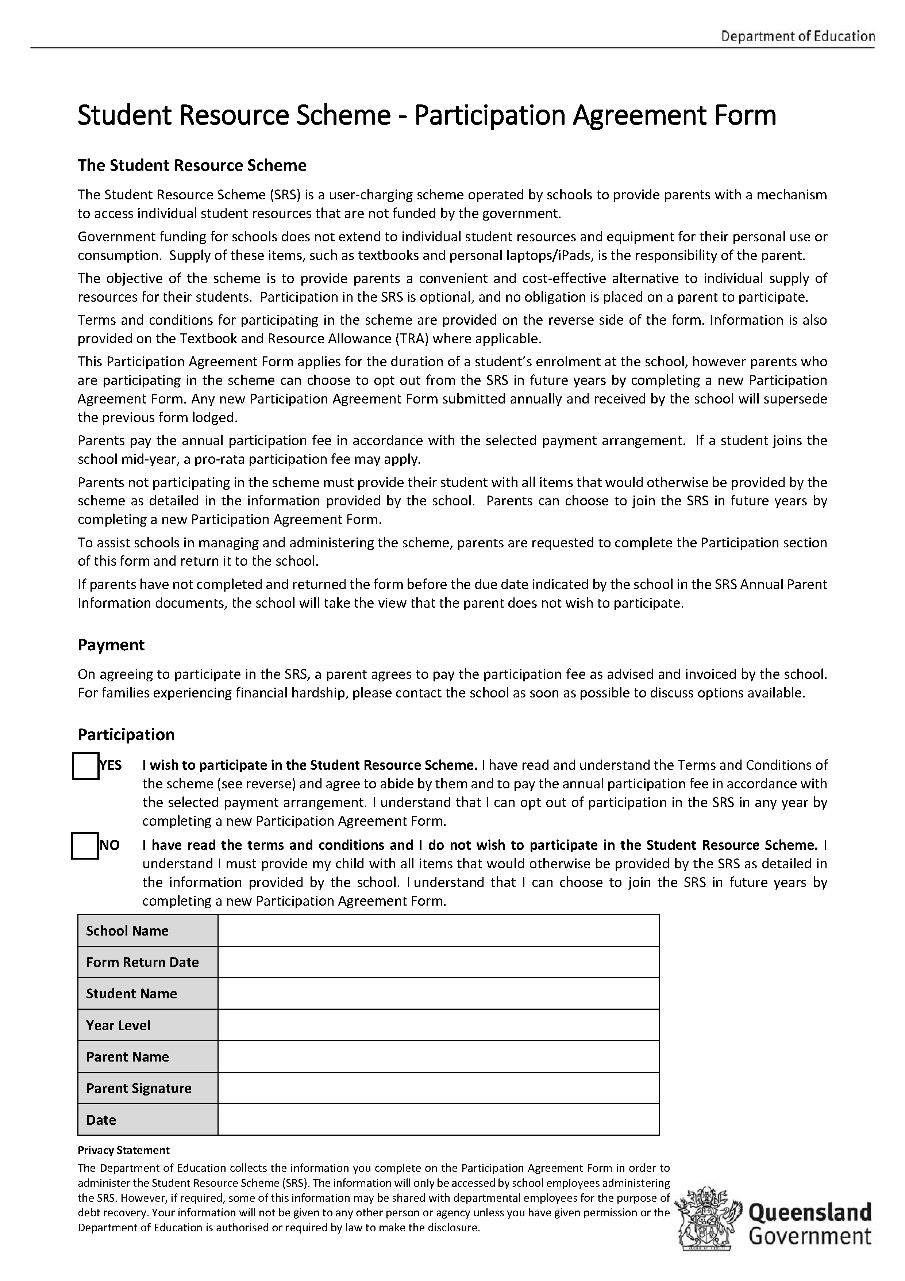

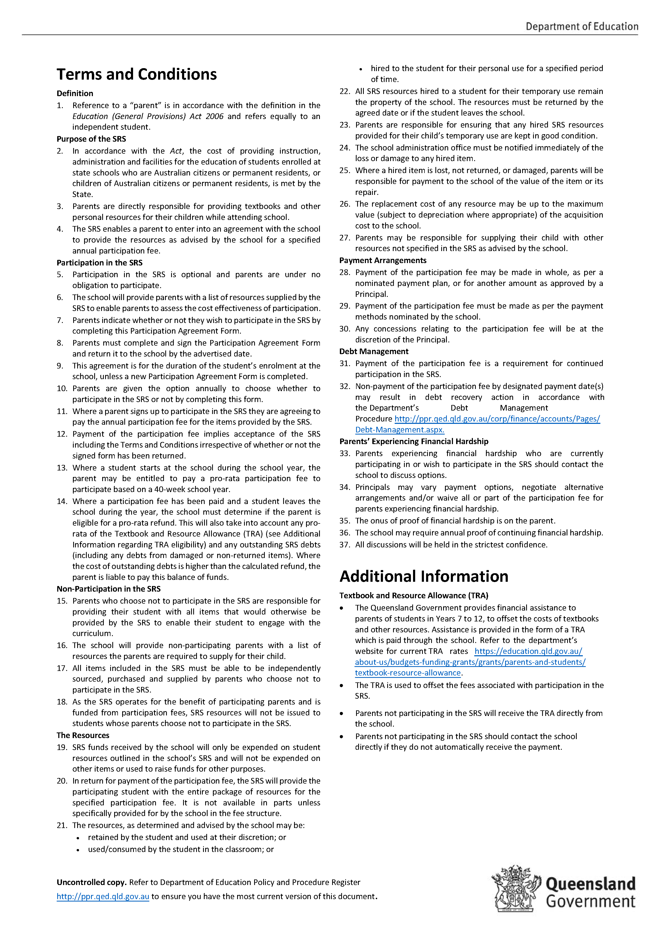


Introduction to the State School Consent Form (attached) for Kuranda District State College
This letter is to inform you about how we will use your child’s personal information and student materials. It outlines:
- what information we record
- how we will use student materials created during your child’s enrolment.
Examples of personal information which may be used and disclosed (subject to consent) include part of a person’s name, image/photograph, voice/video recording or year level.
Your child’s student materials:
- are created by your child whether as an individual or part of a team
- may identify each person who contributed to the creation
- may represent Indigenous knowledge or culture.
Purpose of the consent
It is the school’s usual practice to take photographs or record images of students and occasionally to publish limited personal information and student materials for the purpose of celebrating student achievement and promoting the school and more broadly celebrating Queensland education.
To achieve this, the school may use newsletters, its website, traditional media, social media or other new media as listed in the ‘Media Sources’ section below.
The State School Consent Form may, at your discretion, provide consent for personal information and a licence for the student materials to be published online or in other public forums. It also allows your child’s personal information and student materials to be presented in part or alongside other students’ achievements.
The school needs to receive consent in writing before it uses or discloses your child’s personal information or student materials in a public forum. The attached form is a record of the consent provided.
It should be noted that in some instances the school may be required by the Education (General Provisions) Act 2006 (Qld) or by law to record, use or disclose the student’s personal information or materials without consent (e.g. assessment of student materials does not require further consent).
Voluntary
There will not be any negative repercussions for not completing the State School Consent Form or for giving limited consent. All students will continue to receive their education regardless of whether consent is given or not.
Consent may be limited or withdrawn
Consent may be limited or withdrawn at any time by you.
If you wish to limit or withdraw consent please notify the school in writing (by email or letter). The school will confirm the receipt of your request via email if you provide an email address.
If in doubt, the school may treat a notice to limit consent as a comprehensive withdrawal of consent until the limit is clarified to the school’s satisfaction.
Due to the nature of the internet and social media (which distributes and copies information), it may not be possible for all copies of information (including images of student materials) once published by consent, to be deleted or restricted from use.
The school may take down content that is under its direct control, however, published information and materials cannot be deleted and the school is under no obligation to communicate changes to consent with other entities/ third parties.

Media sources used
Following is a list of online and social media websites and traditional media sources where the school may publish your child’s personal information or student materials subject to your consent.
- School website: https://kurandadistrictsc.eq.edu.au/
- Facebook: https://m.facebook.com/KurandaDSC/
- YouTube: NONE
- Instagram: NONE
- Twitter: NONE
- LinkedIn: NONE
- Other: NONE
- Local newspaper
- School newsletter: Schoolzine (SZapp)
- Traditional and online media, printed materials, digital platforms’ promotional materials, presentations and displays.
The State School Consent Form does not extend to P&C run social media accounts or activities, or external organisations.
Duration
The consent applies for the period of enrolment or another period as stated in the State School Consent Form, or until you decide to limit or withdraw your consent.
During the school year there may be circumstances where the school or Department of Education may seek additional consent.
Who to contact
To return a consent, express a limited consent or withdraw consent please contact the school office and talk the administration team who will advise you who to speak with.
Admin should be contacted if you have any questions regarding consent.

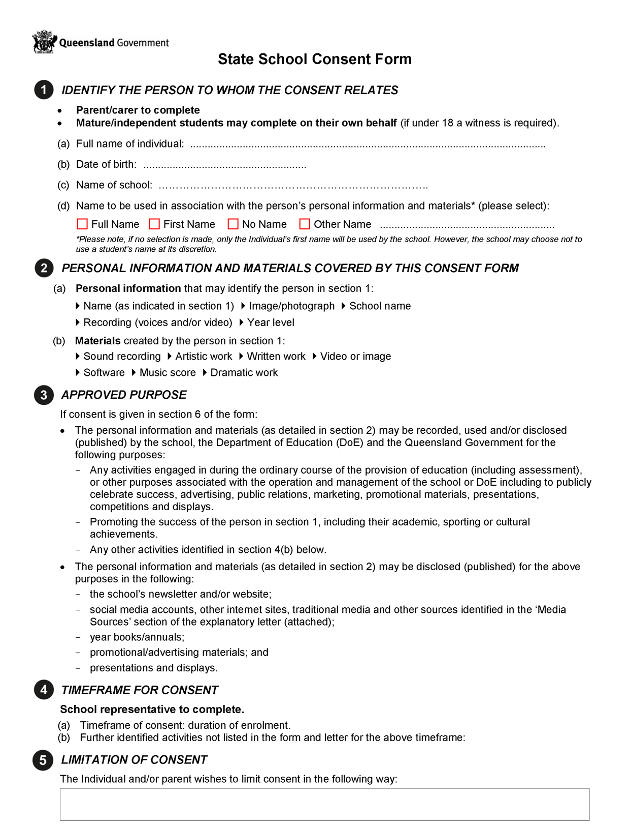

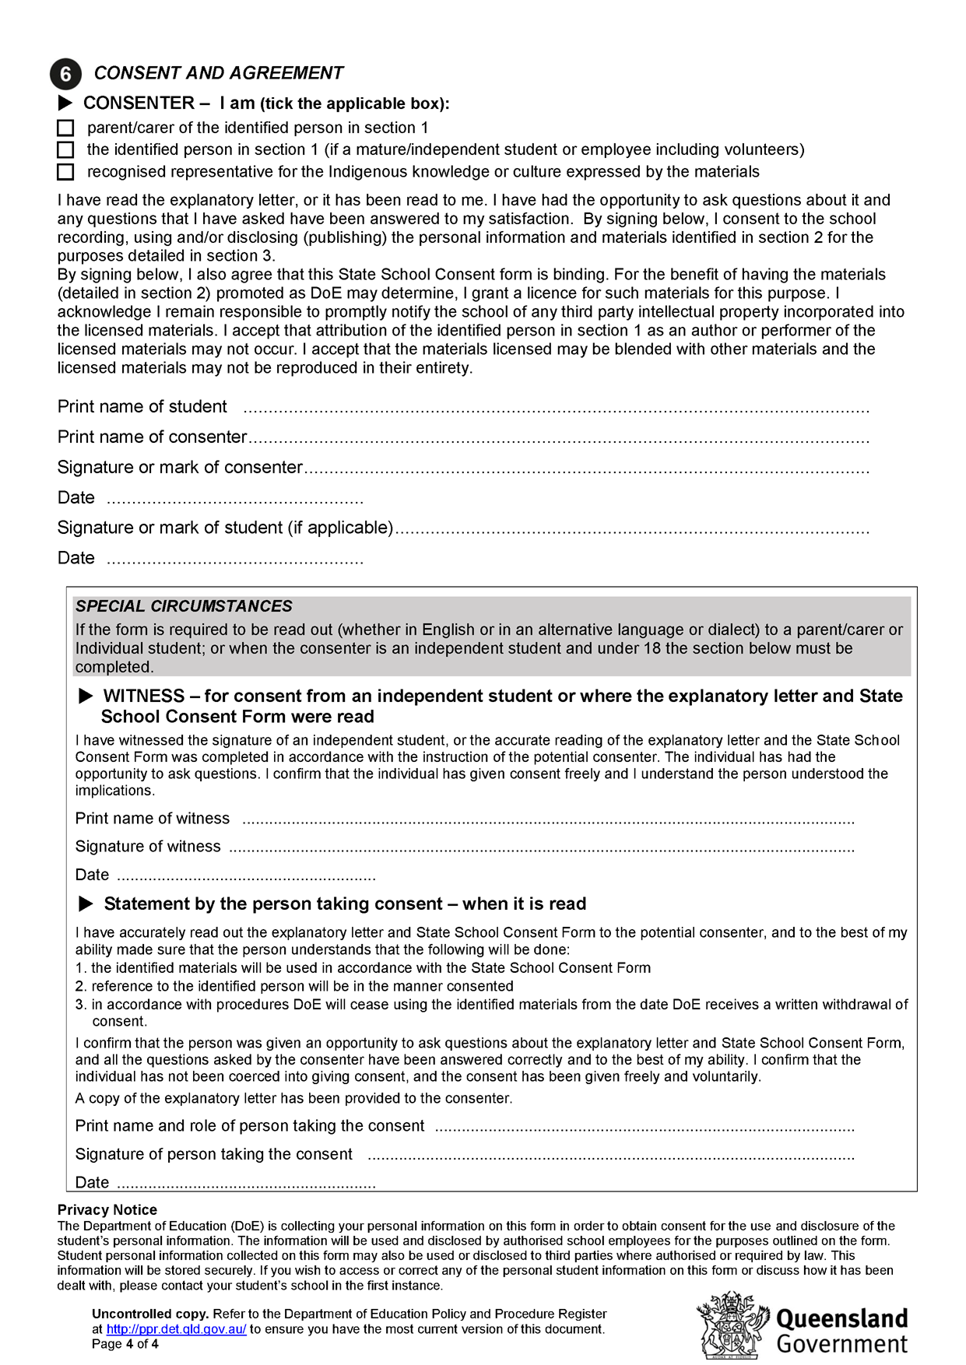

Kuranda District State College

Student Resource Scheme - Parent Information Letter

Dear Parents/Guardians,

This letter contains important information about the 2025 Student Resource Scheme (SRS) including how the scheme operates and the annual participation fee.

The Queensland Government supports students’ education by providing funding for:

• Instruction, e.g. teachers

• Facilities, e.g. buildings, amenities, furniture

• Administration, e.g. staffing and resources to administer the operations of the school.

Funding does not extend to individual student resources such as textbooks, computer or musical equipment for personal

use, and many items used/consumed by the student in the classroom. Supply of these items is the responsibility of parents.

To provide parents with a cost-effective alternative to purchasing textbooks and/or resources elsewhere, Kuranda District State College operates an SRS for 2025.

The scheme ensures that students have the resources required for them to engage with the curriculum for their education, and saves parents time and money in sourcing the prescribed materials elsewhere. Savings are gained through the school’s bulk purchasing practices and hiring arrangements. The scheme is not used to raise funds for other purposes, and revenue collected through the scheme is applied only to the resources and operation of the scheme.

The scheme’s operation, resource inclusions and participation fees were approved by the school’s P&C Association at the meeting held on Wednesday the 30th of November 2022.

SRS Participation

The objective of the scheme is to provide a convenient and cost-effective way for students to access the educational resources necessary to enhance their learning experience at school. The Department encourages parents to participate in the scheme.

Parents are required to complete and return the SRS Participation Agreement Form by 21 of February 2025.

Resource Inclusions

All resources included in the SRS are detailed on the school’s website. This is a comprehensive list of all resources included in the scheme and their associated costs.

School Website: https://kurandadistrictsc.eq.edu.au/

Resource Scheme: https://kurandadistrictsc.eq.edu.au/enrolments/resource-scheme

The Textbook and Resource Allowance

The Department of Education provides a Textbook and Resource Allowance (TRA) to assist parents with the cost of textbooks and other education resources for eligible Years 7 to 12 students. For those students who are eligible to receive the TRA, the TRA will be applied to reduce the cost of participation in the SRS. Information on the TRA can be found on the department’s website (https://education.qld.gov.au/about-us/budgets-funding-grants/grants/parents-and-students/textbook-resource-allowance).

The SRS Participation Fee
YEAR LEVEL | Cost of SRS | TRA | ANNUAL MEMBERSHIP COST  (TO BE PAID BY PARENT/GUARDIAN) | Addition charges apply for  (User Pays) | Cost of SRS  2026
Primary | $205 | $0 | $205 per student | Excursions  Camps  Special Events, etc… | TBD
Secondary 7 - 10 | $401 | $155 | $265 per student | Excursions  Camps  Special Events, etc… | TBD
Secondary 11 - 12 | $546 | $337 | $265 per student | Excursions  Camps  Special Events, etc… | TBD

Payment & Billing

Invoices will be generated in the first few weeks of Term 1, 2025.
Payment can be made directly through the BPoint link appearing on your invoice once received.

Payment Arrangement
Payment options including a single payment for the full year’s fee or instalments are available.
An instalment plan can also be negotiated with the school.
Any unpaid invoices, will be managed according to the department’s Debt Management Procedure and may result in the student being excluded from the scheme and/or from participating in non-curricular activities until payment is made (https://ppr.qed.qld.gov.au/attachment/debt-management-procedure.pdf).

Financial Hardship
Parents experiencing financial hardship who are currently participating or wish to participate in the SRS should contact the school to discuss available options in confidence.

Preferred Payment Methods

SRS payments can be made by QParent/BPOINT, Centrepay.

Option 1) – BPOINT one off payment using a Credit Card. https://www.bpoint.com.au/payments/dete

When paying by BPOINT, please use the Customer Reference Number (CRN) and invoice number printed on the invoice received from the school. If unsure of the CRN, please contact the school.

Option 2) – CentrePay – Deduction Form can be collected and returned through the school office.

*Minimum payment plan of $40.00 per student per fortnight.

Centrepay Deductions are available to pay the SRS fees. Use Centrepay to make regular deductions from your Centrelink payment. Centrepay is a voluntary and easy payment option available to Centrelink customers. Go to https://www.servicesaustralia.gov.au/centrepay for more information on how to set up your Centrepay deductions.

Contact Us
For all queries regarding the SRS and its inclusions, please visit the school website https://kurandadistrictsc.eq.edu.au/enrolments/resource-scheme, before contacting the school office on: 4085 5333.
Please complete the SRS Fee Payment Arrangement Form and return to the school administration office by Friday the 21st February 2025.

INTERNET / COMPUTER AGREEMENT

STUDENT

I understand that the Internet can connect me to useful information stored on computers around the world. While I have access to Computer and the Internet:
- I will use it only for educational purposes.
- I will not look for anything that is illegal, dangerous or offensive. If I accidentally come across something that is illegal, dangerous or offensive, I will clear any offensive pictures or information from my screen; and immediately, quietly inform my teacher.
- I will not reveal home addresses or phone numbers (mine or anyone else’s).
- I will not use Computers or Internet to annoy or offend anyone.
- I understand that if the school decides I have broken the rules, appropriate action will be taken. This may include loss of Internet access for some time.

_________________________ __________________________ ______________
Student’s Name Student’s Signature Date

PARENT or CARER

I understand that the Internet can provide students with valuable learning experiences. I also understand that it gives access to information on Computers around the world; that the school cannot control what is on those Computers; and a very small part of that information can be illegal, dangerous or offensive. I accept that, while teachers will always exercise their duty of care, protection against exposure to harmful information should depend finally upon responsible use by students. I believe my child understands this responsibility and I hereby give my permission for him/her to access the Internet under the school rules. I understand that students breaking these rules will be subject to appropriate action by the school. This may include loss of Internet access for some time.

_________________________ __________________________ ______________
Parent or Carer Name Parent or Carer Signature Date

KDSC SCHOOL CLASS PHOTOS PERMISSION

Student Name: _____________________ Year Level: ____
Date of Birth: ____/____/_____

☐ YES – I would like my child to participate in school/class photos (Including leader and sports captains) and understand that for this to happen their full legal name will be used and placed on the school photos along with their class.

☐ NO – My child is not to participate in school/class photos (Including leader and sports captains) and I understand by saying no to this my child will not appear in the photos at all.

I understand I can change this at any point by completing a new form and returning it to the office.

Name: ____________________ Signature: _______________
Date: ____/____/_____

