Social and Emotional Learning

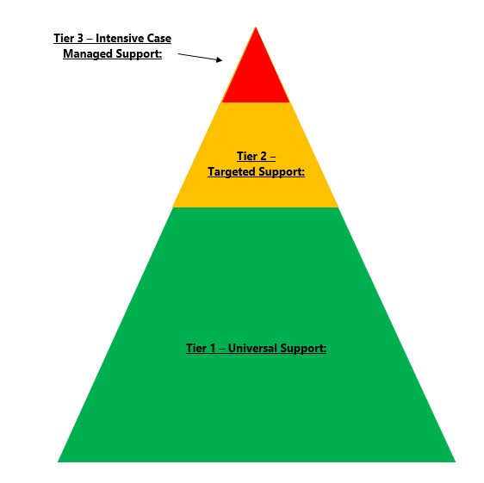

Tier 1 – Prep – Year 10 Resilience, Rights and Respectful Relationships
Kuranda District State College implement a college wide program that covers eight topics of Social and Emotional Learning. These eight topics include: Emotional Literacy, Personal Strengths, Positive Coping, Problem Solving, Stress Management, Help-Seeking, Gender and Identify and Positive Gender Relations.

Tier 2 – Small Group Social and Emotional Intervention Groups
Kuranda District State College facilitate small group interventions on both primary and secondary campus focusing on specific topics. These interventions include practices such as social skills, self/social management and self/social awareness.

Tier 3 – Intensive 1:1 Zones of Regulation
Kuranda District State College implement 1:1 social and emotional learning program called ‘Zones of Regulation’. This program is a systematic, cognitive behavioral approach used to teach others to self-regulate their needs as well as their emotions and impulses in order to meet the demands of the environment and be successful socially.

