STUDENT NAME:__________________________ YEAR:_____ INTENDED START DATE___/___ /____
Parent/Carer Checklist | Parent/Carer  Tick & Initial
BIRTH CERTIFICATE / PASSPORT supplied to school and copy made for student file  Website: www.qld.gov.au/birthcertificate | ☐
I have completed and signed the APPLICATION FOR STUDENT ENROLMENT FORM | ☐
I have completed and signed the STUDENT RESOURCE SCHEME – PARTICIPATION AGREEMENT FROM | ☐
I have completed and signed the STATE SCHOOL CONSENT FORM and indicated what name to be used and filled in all the boxes with information. | ☐
I have School Photography CONSENT FORM | ☐
I have completed and signed the INTERNET ACCESS AGREEMENT | ☐
I have completed and signed the ONLINE SERVICE CONSENT FORM | ☐
I have completed the SUBJECT SELECTION form (Years 7 to 12)  Website: https://kurandadistrictsc.eq.edu.au | ☐
I have organised PAYMENT of SCHOOL FEES with ACCOUNTS RECEIVABLE | ☐
I have a copy of the STUDENT ABSENCES (SAME DAY NOTIFICATION) information and am aware of what needs to happen and will happen if my child is away. | ☐
I have a copy of the GOOD STANDING POLICY and have read understood aware of what needs to happen and will happen if my child is away. | ☐
I have purchased my child’s SCHOOL UNIFORM | ☐
I have a copy of the TUCKSHOP MENU | ☐

Application for student enrolment form

INSTRUCTIONS
Please refer to the Application to enrol in a Queensland State School information sheet at the end of this form when completing this application.
Failure or refusal to complete those sections of the form marked with an (*) or to provide required documentation may result in a refusal to process your application. Sections of the form not marked (*) are optional. However, failure to complete these sections may result in the school not being eligible for important Federal and State Government funding reliant on such information. Parents of all students in Australia have been asked to provide information on their family background as part of a
national initiative towards providing an education system that is fair to all students, regardless of their background. The required information includes the Indigenous
status and language background of the student, and the education, occupation and language background of the parents.
If you have any questions about the enrolment form or process, or require assistance completing this form, including translation services, please contact the school in the first instance.

PRIVACY STATEMENT
The Department of Education (DoE) is collecting the information on this form for the purposes outlined in the Education (General Provisions) Act 2006 (EGPA 2006), and in particular for:
- assessing whether your application for enrolment should be approved
- meeting reporting obligations required by law or under Federal – State Government funding arrangements
- administering and planning for providing appropriate education, training and support services to students
- assisting departmental staff to maintain the good order and management of schools, and to fulfil their duty of care to all students and staff
- communicating with students and parents.
This collection is authorised by ss. 155 and 428 of the EGPA 2006. DoE will disclose personal information from this form to the Queensland Curriculum and Assessment Authority when opening student accounts, in compliance with Part 3 of the Education (Queensland Curriculum and Assessment Authority) Act 2014 (Qld). Personal Information from this form will also be supplied to Centrelink in compliance with ss.194 and 195 of the Social Security (Administration) Act 1999 (Cth). De-identified information concerning parents’ school and non-school education, occupation group and main language other than English and students’ country of birth, main language other than English, sex and Indigenous status, is supplied to the Australian Government Department of Education in compliance with Federal – State Government funding agreements.
Personal information collected on this form may also be disclosed to third parties where authorised or required by law. Your information will be stored securely. If you wish to access or correct any of the personal information on this form or discuss how it has been dealt with, please contact the school in the first instance. If you have a concern or complaint about the way your personal information has been collected, used, stored or disclosed, please also contact the school in the first instance.
ENTITLEMENT TO ENROLMENT
Under the EGPA 2006, an applicant for enrolment at a state school must be enrolled if they are entitled to enrolment. While not exhaustive, the following matters may affect an applicant’s entitlement to enrolment at a state school:
- failure to adequately complete this enrolment form
- if the school has an Enrolment Management Plan or an Enrolment Eligibility Plan (enrolment is subject to eligibility under the plan)
- the applicant is a prospective mature age student (the applicant can only apply for enrolment at a mature age state school and will be subject to a satisfactory criminal history check, or as a student in a program of distance education. All prospective mature age students must have a remaining allocation of state education.)
- the applicant is not of correct age for enrolment (relates to Preparatory Year and Years 1 to 6)
- the applicant has been excluded or cancelled from enrolment or is subject to suspension from a state school at the time of the application
- the school is a state special school and the applicant does not meet the criteria for enrolment in a special school
- the school principal reasonably believes that the applicant presents an unacceptable risk to the safety or wellbeing of members of the school community (application is referred to Director-General)
- the proposed enrolment requires approval as part of a flexible arrangement under s.183 of the EGPA 2006, and the arrangement has not yet been approved
- the prospective student is not an Australian resident or citizen or the child of an Australian permanent resident or citizen (visa restrictions may apply, fees may be charged, in some cases legislation requires that the applicant must obtain approval from the Chief Executive via Education Queensland International (EQI) to enrol).

Office use only
Date enrolled |  | / / |  | Year level |  |  | Roll Class |  | EQ ID
Independent student |  | Yes No |  |  |  |  | Birth certificate/passport sighted, number recorded and DOB confirmed |  |  |  | Yes No  Number:
Is the prospective student over 18 years of age at the time of enrolment
Yes No
If yes, is the prospective student exempt from the mature age student process?
If no, has the prospective mature age student consented to a criminal history Yes No check? Yes No
School house/ team |  |  |  |  |  |  | EAL/D support |  |  |  | Yes No  To be determined
FTE |  |  | Associated unit |  |  |  | Visa and associated documents sighted |  |  |  | Yes No
EQI category |  |  |  |  |  |  | SV – student visa EX – exchange student  TV – temporary visa DE – distance education DS – dependent – parent on student visa

PROSPECTIVE STUDENT DEMOGRAPHIC DETAILS
Legal family name*
(as per birth certificate)
Legal given names*
(as per birth certificate)
Preferred family name |  | Preferred given names
Sex* | Male Female | Date of birth* | / /
Copy of birth certificate available to show school staff* | Yes No | Enrolment may not be approved without enrolling staff sighting the prospective student’s birth certificate. An alternative to birth certificate will be considered where it is not possible to obtain a birth certificate (e.g. prospective student born in country without birth registration system. Passport or visa documents will suffice). This does not include failure to register a birth or reluctance to order a birth certificate.  For international students approved for enrolment by EQI, a passport or visa will be acceptable.
For prospective mature age students, proof of identity supplied and copied* | Yes No | Prospective mature age students must provide photographic identification which proves their identity:  - current driver’s licence; or  - adult proof of age card; or  - current passport.

APPLICATION DETAILS
Has the prospective student ever attended a Queensland state school? | Yes No | If yes, provide name of school and approximate date of enrolment.
What year level is the prospective student seeking to enrol in? |  | Please provide the appropriate year level.
Proposed start date | / / | Please provide the proposed starting date for the prospective student at this school.
Does the prospective student have a sibling attending this school or any other Queensland state school? | Yes No | If yes, provide name of sibling, year level, date of birth, and school | Name:
 |  |  | Year Level
 |  |  | Date of birth | / /
 |  |  | School

PROSPECTIVE STUDENT ADDRESS DETAILS*
Principal place of residence address
Address line 1
Address line 2
Suburb/town |  | State |  | Postcode
Mailing address (if it is the same as principal place of residence, write 'AS ABOVE')
Address line 1
Address line 2
Suburb/town |  | State |  | Postcode
Email

FAMILY DETAILS
Parents/carers | Parent/carer 1 |  |  |  |  | Parent/carer 2
Family name*
Given names*
Title | Mr | Mrs | Ms | Miss | Dr | Mr | Mrs | Ms | Miss | Dr
Sex | Male | Female |  |  |  | Male | Female
Relationship to prospective student*
Is the parent/carer an emergency contact? | Yes | No |  |  |  | Yes | No

Parents/carers | Parent/carer 1 |  |  | Parent/carer 2
1st Phone contact number for SMS correspondence | Mobile |  |  | Mobile
2nd Phone contact number* | Work/home/mobile |  |  | Work/home/mobile
3rd Phone contact number* | Work/home/mobile |  |  | Work/home/mobile
Email
Employer name
Occupation
What is the occupation group of the parent/carer? | (Please select the parental occupation group from the list provided at the end of this form. If parent/carer 2 is not currently in paid work but has had a job in the last 12 months or has retired in the last 12 months, please use the last occupation. If parent/carer 2 has not been in paid work in the last 12 months, enter ‘8’) |  |  | Please select the parental occupation group from the list provided at the end of this form. If parent/carer 2 is not currently in paid work but has had a job in the last 12 months or has retired in the last 12 months, please use the last occupation. If parent/carer 2 has not been in paid work in the last 12 months, enter ‘8’)
Country of birth
Country of residence
Does parent/carer 1 or parent/carer 2 speak a language other than English at home? (If more than one language, indicate the one that is spoken most often) | No, English only  Yes, other – please specify  Needs interpreter? Yes No |  |  | No, English only  Yes, other – please specify  Needs interpreter? Yes No
Is the parent/carer an Australian citizen? | Yes No |  |  | Yes No
Is the parent/carer a permanent resident of Australia? | Yes No |  |  | Yes No
Address line 1
Address line 2
Suburb/town
State |  | Postcode |  |  | Postcode
Address line 1
Address line 2
Suburb/town
State |  | Postcode |  |  | Postcode
Parent/carer school education | What is the highest year of primary or secondary school parent/carer 1 has completed? (For people who have never attended school, mark 'Year 9 or equivalent or below') |  |  | What is the highest year of primary or secondary school parent/carer 2 has completed? (For people who have never attended school, mark 'Year 9 or equivalent or below')
Year 9 or equivalent or below
Year 10 or equivalent
Year 11 or equivalent
Year 12 or equivalent
Parent/carer non-school education | What is the level of the highest qualification parent/carer 1 has completed? |  |  | What is the level of the highest qualification parent/carer 2 has completed?
Certificate I to IV (including trade certificate)
Advanced Diploma/Diploma
Bachelor degree or above
No non-school qualification

PROSPECTIVE STUDENT ORIGIN DETAILS
Origin | Queensland/interstate/overseas
Origin type | Childcare centre or kindergarten/Prep/primary/secondary/VET/other
Previous school/other location
Previously employed | Yes No | Full-time Part-time

INDIGENOUS STATUS
Is the prospective student of Aboriginal or Torres Strait Islander origin? | No Aboriginal Torres Strait Islander Both Aboriginal and Torres Strait Islander

RELIGION – RELIGIOUS INSTRUCTION*
From Year 1, the prospective student may participate in religious instruction if it is available.  If you tick ‘No’ or if the nominated religion is not represented within the school’s religious instruction program, the prospective student will receive other instruction in a separate location during the period arranged for religious instruction.  Parents/carers may change these arrangements at any time by notifying the principal in writing. | Do you want the prospective student to participate in religious instruction?
 | Yes No
 | If ‘Yes’, please nominate the religion:

COUNTRY OF BIRTH*
In which country was the prospective student born? | Australia  Other (please specify country)  Date of arrival in Australia / _/
Is the prospective student an Australian citizen? | Yes No (if no, evidence of the prospective student's immigration status to be completed)

PROSPECTIVE STUDENT LANGUAGE DETAILS
Does the prospective student speak a language other than English at home? | No, English only  Yes, other – please specify

EVIDENCE OF PROSPECTIVE STUDENT'S IMMIGRATION STATUS (to be completed if this person is NOT an Australian citizen)*
Permanent resident | Complete passport and visa details section below
Student visa holder | Date of arrival in Australia _/ _/ |  | Date enrolment approved to: _/ /
 | EQI receipt number:
Temporary visa holder | Complete passport and visa details section below
Other, please specify  _______________________________ | Temporary visa holders must obtain an 'Approval to enrol in a state school' from EQI
Passport and visa details (to be completed for a prospective student who is NOT an Australian citizen).
NOTE: A permanent resident will have a passport with a permanent residency visa inside worded ‘Holder(s) permitted to remain in Australia indefinitely’.
For prospective students arriving in Australia as refugee or humanitarian entrants, either PLO 56 Immigration issued card or ‘Document to travel to Australia’ with ‘stay indefinite’ recorded must be sighted by the school.
Passport number |  | Passport expiry date |  | / /
Visa number |  | Visa expiry date (if applicable) |  | / /
Visa sub class

EMERGENCY CONTACT DETAILS (Other emergency contact details if parents/carers listed previously are not emergency contacts or cannot be contacted)*
 | Emergency contact | Emergency contact
Name
Relationship (e.g. aunt)
1st phone contact number* | Work/home/mobile | Work/home/mobile
2nd phone contact number* | Work/home/mobile | Work/home/mobile
3rd phone contact number* | Work/home/mobile | Work/home/mobile

PROSPECTIVE STUDENT MEDICAL INFORMATION (including allergies)*
Privacy Statement
The Department of Education (DoE) is collecting this medical information in order to address the medical needs of students during school
hours as well as during school excursions, school camps, sports and other school activities. DoE will not use this information to make a decision about a prospective student’s eligibility for enrolment. The information will only be used by authorised employees of the department and DoE will only record,
use and disclose the medical information in accordance with the confidentiality provisions at Section 426 of the Education (General Provisions) Act 2006.
It is essential that the school is advised before the prospective student’s first day of attendance if the prospective student has any medical conditions. The school administration staff must also be informed of any new medical conditions or a change to medical conditions as soon as they are known.
Should the prospective student need to take medication during school hours, an Individual Health Plan, including Emergency Health Plan if relevant, or Authority to Administer Medication Form will need to be completed each year and retained at the office.
No known medical conditions
Medical condition (including allergies/sensitivities), symptoms and management (please refer to the list of Medical Condition categories provided)
Medical condition (including allergies/sensitivities), symptoms and management (please refer to the list of Medical Condition categories provided)
Medical condition (including allergies/sensitivities), symptoms and management (please refer to the list of Medical Condition categories provided)
Does the prospective student require any medical aids or devices (such as glasses, contact lenses, prosthetics or orthotics)? This is for the purpose of informing planning for school activities such as sport and school excursions. | No | Yes, please specify
Name of prospective student's medical practitioner (optional) |  |  |  |  | Contact number of medical practitioner
I authorise school staff to contact the prospective student’s medical practitioner for the purposes of seeking advice in cases where an immediate but non-life threatening response is required (for instance, when the prospective student may be on an excursion or sporting event)? (answer only if medical practitioner details have been provided above) |  |  |  |  |  | Yes | No
Medicare card number  (optional) |  |  |  |  | Position Number
Card Colour | Green |  | Yellow | Blue | Expiry Date | / /
Cardholder name (if not in name of prospective student)
Private health insurance company name (if covered) (optional) |  |  |  |  | Private health insurance membership number (leave blank if company name is not provided)

SCHOOL FEES & FINANCIAL RESPONSIBILITY
Student Full Name

FINANCIAL RESPONSIBILITY
Our School has the ability to split invoices for all student costs and activities. Split invoices are for students who have separated parents and both parents have shared financial responsibility for their child. This means you will only be invoiced for the amount you are required to contribute.

Financial responsibility is the parent or carer who takes care and responsibility for the associated students account and makes sure it is paid.
Parent/Carer
Relationship to student
Phone
Mailing Address
Suburb/town |  | State |  | Postcode
Email
Signature |  |  |  | Date

FINANCIAL RESPONSIBILITY ( SEPARATED PARENTS & SPLIT FAMILIES ONLY)
Parents/Carers | Parent/Carer 1 |  |  | Parent/Carer 2
Family name
Given names
Relationship to prospective student
Percentage of Shared Cost | □ 50% | or | % | □ 50% | or | %
Phone
Mailing Address
Suburb/Town
State
Postcode
Email
Signature
Date
BANK ACCOUNT DETAILS (PARENT REFUNDS)
With invoicing and payments of the Student Resource Scheme, excursions, camps, and other school events you may be entitled to a refund. In order to refund money back to the payee, the payee needs to supply their bank account details.
Account Name
BSB
Account Number
Bank
Branch
Signature

COURT ORDERS*
Out-of-Home Care Arrangements*
Under the Child Protection Act 1999, when a Child Protection Order is approved by the Children’s Court, the child is placed in out-of-home care (OOHC). Out-of-home care includes short or long term placement with an approved kinship or foster carer; in a supported independent living arrangement; in a safe house; and in residential care.
Is the prospective student identified as residing in out-of-home care? | Yes No
If yes, what are the dates of the court order? Please provide a copy of the court order and/or the Authority to Care. | Commencement date | / /
 | End date | / /
Contact details of the Child Safety Officer (if known) | Name
 | Phone number
Family Court Orders*
Are there any current orders made pursuant to the Family Law Act 1975 concerning the welfare, safety or parenting arrangements of the prospective student? | Yes No
If yes, what are the dates of the court order? Please provide a copy of the court order. | Commencement date |  | / /
 | End date |  | / /
Other Court Orders*
Are there any other current court orders, such as a domestic violence order, concerning the welfare, safety or parenting arrangements of the prospective student? | Yes No
If yes, what are the dates of the court order? Please provide a copy of the court order. | Commencement date |  | / /
 | End date |  | / /

TRAVEL DETAILS
Mode of transport to school | Walk Car Bus Bicycle  Other

BUS ROUTE
Which bus is your student travelling on? | Koah Kowrowa Mantaka Speewah Top of the Range  Town Bus

APPLICATION TO ENROL*
I hereby apply to enrol my child or myself at _.

I understand that supplying false or incorrect information on this form may lead to the reversal of a decision to approve enrolment. I believe that the information. I have supplied on this form is true and correct in every particular, to the best of my knowledge.
 | Parent/carer 1 | Parent/carer 2 | Prospective student
Signature
Date | / / | / / | / /

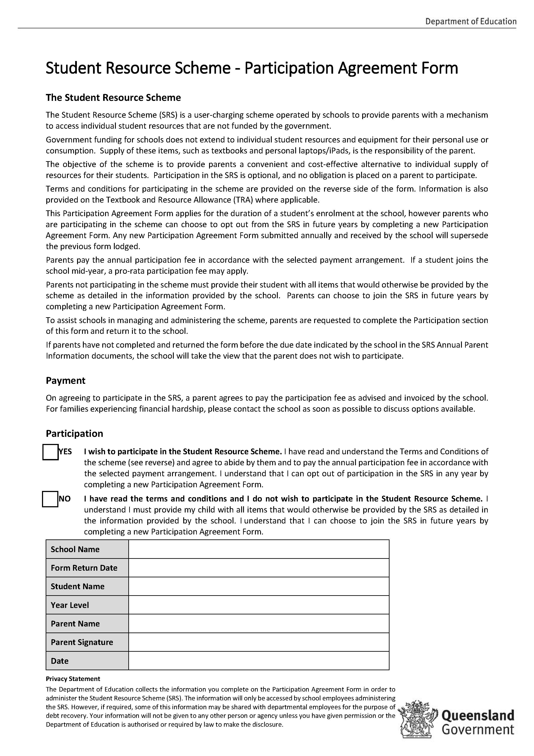
Kuranda District State College
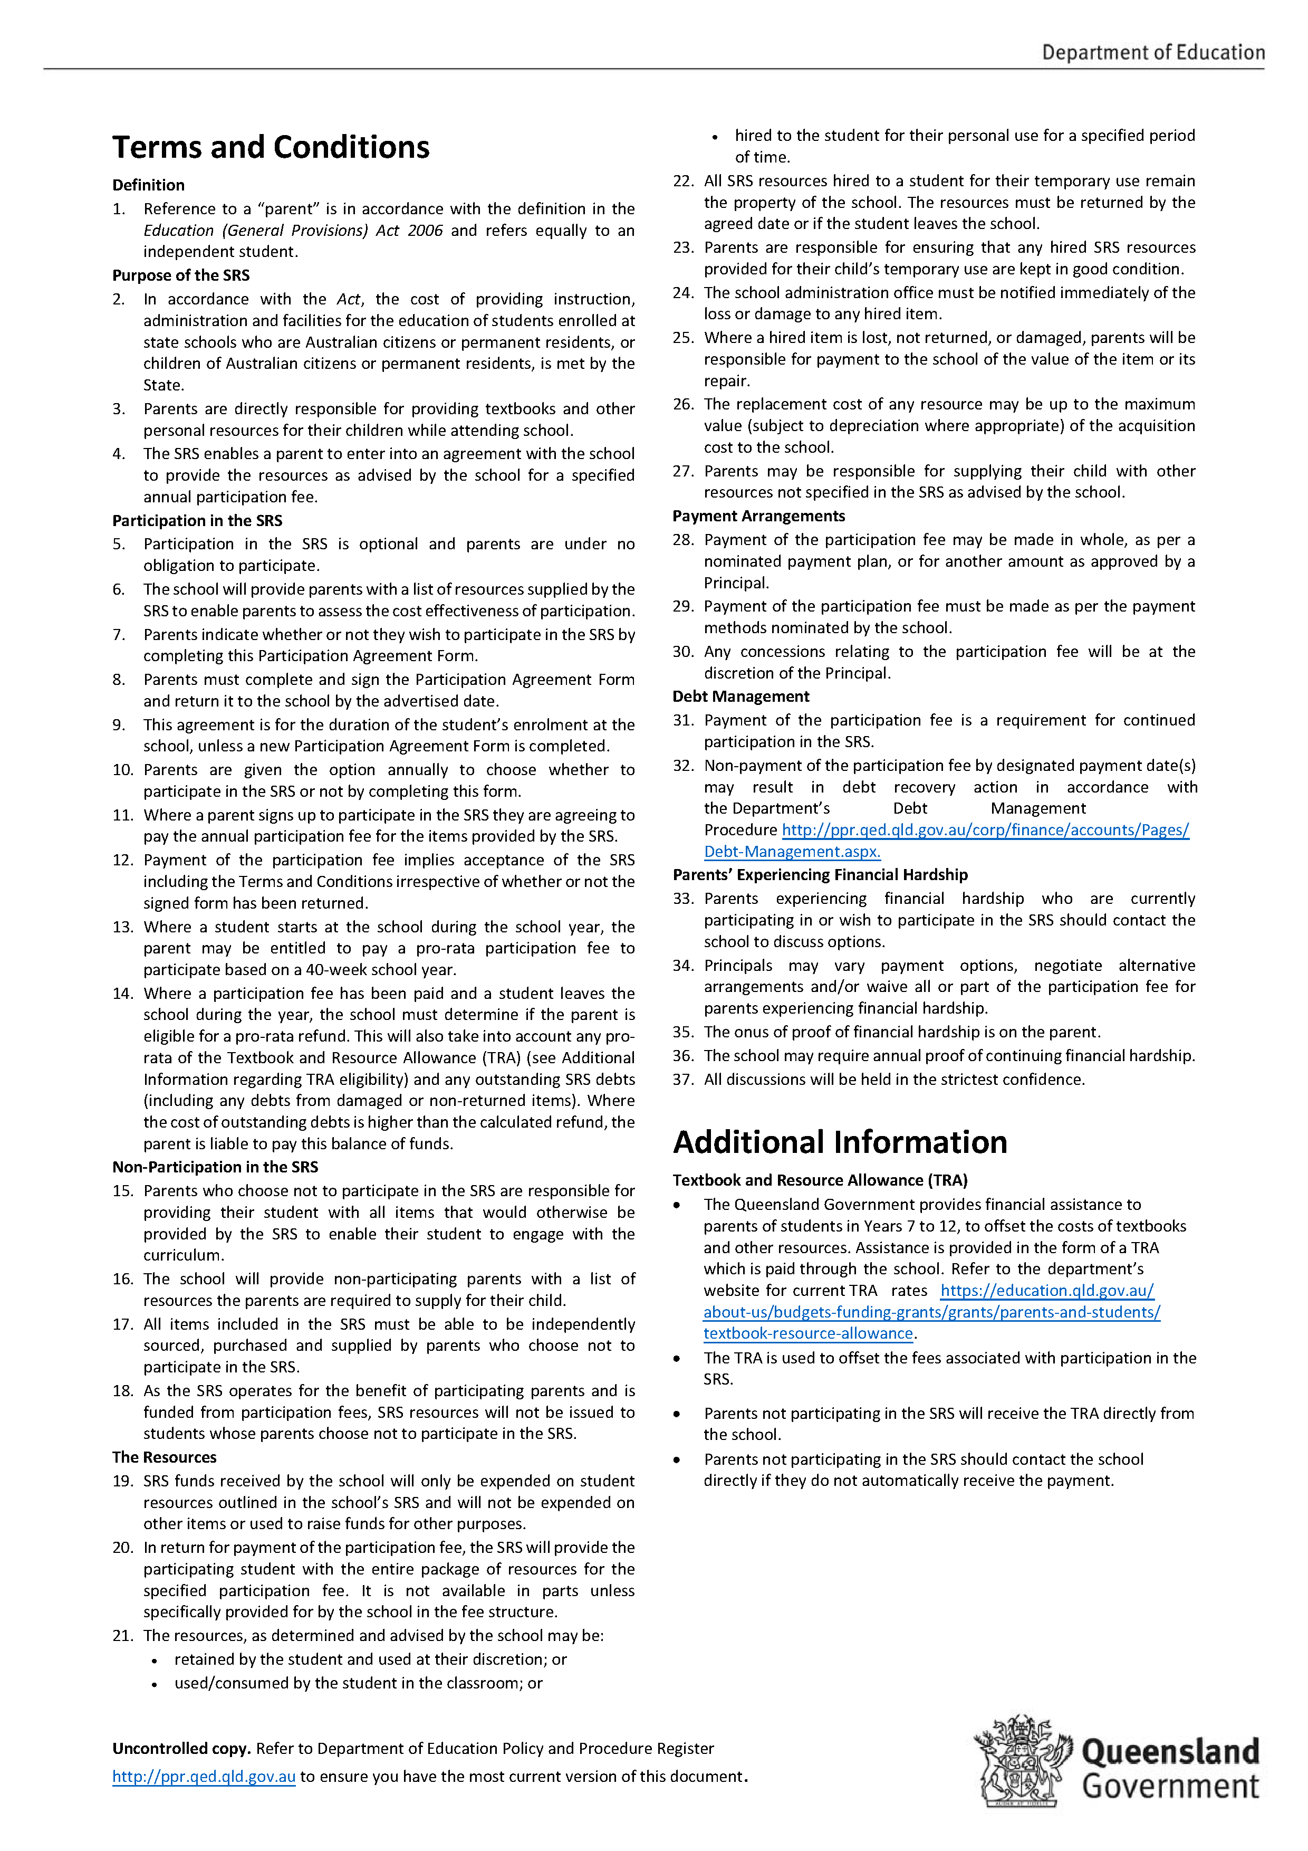

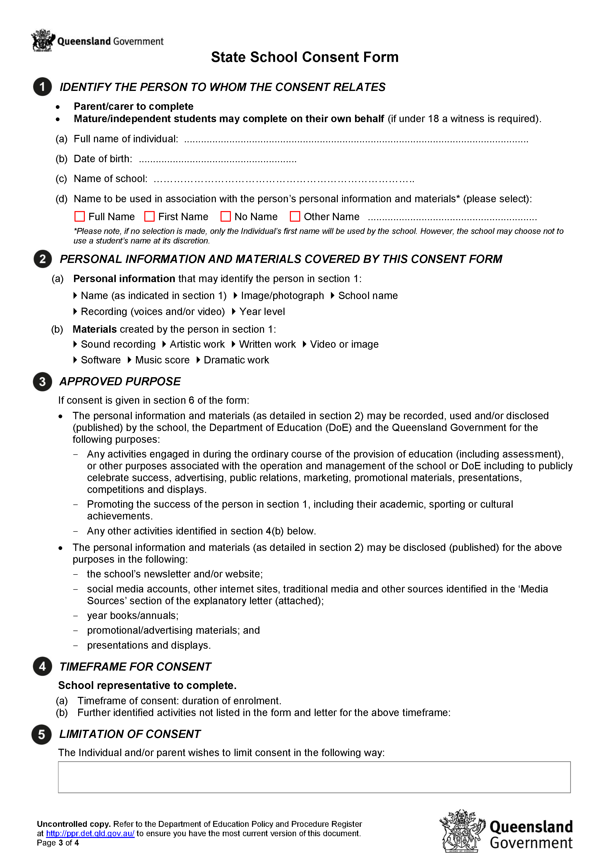

KURANDA DISTRICT STATE COLLEGE

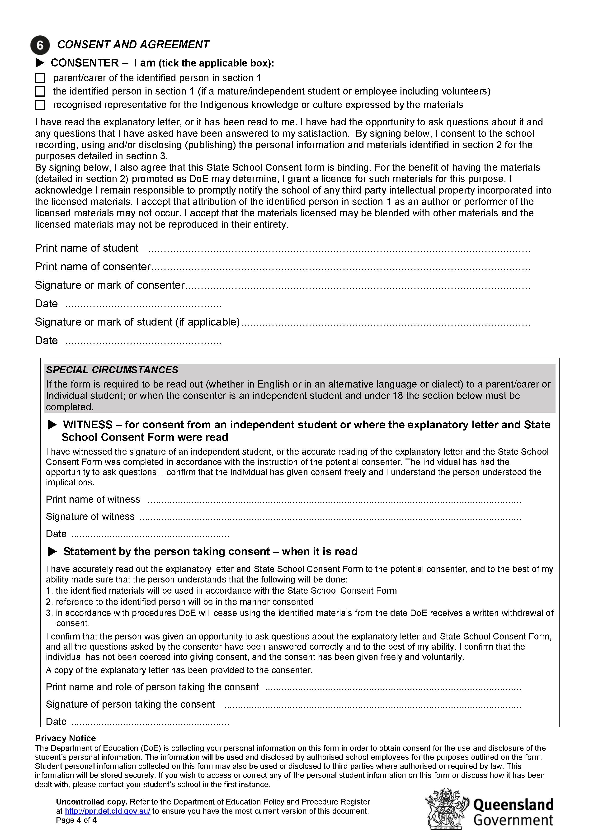

INTERNET / COMPUTER AGREEMENT

STUDENT

I understand that the Internet can connect me to useful information stored on computers around the world. While I have access to Computer and the Internet:
- I will use it only for educational purposes.
- I will not look for anything that is illegal, dangerous or offensive. If I accidentally come across something that is illegal, dangerous or offensive, I will clear any offensive pictures or information from my screen; and immediately, quietly inform my teacher.
- I will not reveal home addresses or phone numbers (mine or anyone else’s).
- I will not use Computers or Internet to annoy or offend anyone.
- I understand that if the school decides I have broken the rules, appropriate action will be taken. This may include loss of Internet access for some time.

_________________________ __________________________ ______________
Student’s Name Student’s Signature Date

PARENT or CARER

I understand that the Internet can provide students with valuable learning experiences. I also understand that it gives access to information on Computers around the world; that the school cannot control what is on those Computers; and a very small part of that information can be illegal, dangerous or offensive. I accept that, while teachers will always exercise their duty of care, protection against exposure to harmful information should depend finally upon responsible use by students. I believe my child understands this responsibility and I hereby give my permission for him/her to access the Internet under the school rules. I understand that students breaking these rules will be subject to appropriate action by the school. This may include loss of Internet access for some time.

_________________________ __________________________ ______________
Parent or Carer Name Parent or Carer Signature Date

KDSC SCHOOL CLASS PHOTOS PERMISSION

Student Name: _____________________ Year Level: ____
Date of Birth: ____/____/_____

☐ YES – I would like my child to participate in school/class photos (Including leader and sports captains) and understand that for this to happen their full legal name will be used and placed on the school photos along with their class.

☐ NO – My child is not to participate in school/class photos (Including leader and sports captains) and I understand by saying no to this my child will not appear in the photos at all.

I understand I can change this at any point by completing a new form and returning it to the office.

Name: ____________________ Signature: _______________
Date: ____/____/_____

Parental occupation groups for use with parent/carer details
Group 1: Senior management in large business organisation, government administration and defence, and qualified professionals

Senior executive/manager/department head in industry, commerce, media or other large organisation.
Public service manager [section head or above], regional director, health/education/police/fire services administrator Other administrator [school principal, faculty head/dean, library/museum/gallery director, research facility director] Defence Forces commissioned officer
Professionals generally have degrees or higher qualifications and experience in applying this knowledge to design, develop or operate complex systems; identify, treat and advise on problems; and teach others
Health, education, law, social welfare, engineering, science, computing professional
Business [management consultant, business analyst, accountant, auditor, policy analyst, actuary, valuer]
Air/sea transport [aircraft/ship’s captain/officer/pilot, flight officer, flying instructor, air traffic controller].
Group 2: Other business managers, arts/media/sportspeople and associate professionals

Owner/manager of farm, construction, import/export, wholesale, manufacturing, transport, real estate business
Specialist manager [finance/engineering/production/personnel/industrial relations/sales/marketing]
Financial services manager [bank branch manager, finance/investment/insurance broker, credit/loans officer]
Retail sales/services manager [shop, petrol station, restaurant, club, hotel/motel, cinema, theatre, agency]
Arts/media/sports [musician, actor, dancer, painter, potter, sculptor, journalist, author, media presenter, photographer, designer, illustrator, proof- reader, sportsperson, coach, trainer, sports official]
Associate professionals generally have diploma/technical qualifications and support managers and professionals
Health, education, law, social welfare, engineering, science, computing technician/associate professional
Business/administration [recruitment/employment/industrial relations/training officer, marketing/advertising specialist, market research analyst, technical sales representative, retail buyer, office/project manager]
Defence Forces senior Non-Commissioned Officer.
Group 3: Tradespeople, clerks and skilled office, sales and service staff

Tradespeople generally have completed a four year trade certificate, usually by apprenticeship. All tradespeople are included in this group
Clerks [bookkeeper, bank/PO clerk, statistical/actuarial clerk, accounting/claims/audit clerk, payroll clerk, recording/registry/filing clerk, betting clerk, stores/inventory clerk, purchasing/order clerk, freight/transport/shipping clerk, bond clerk, customs agent, customer services clerk, admissions clerk]
Skilled office, sales and service staff:
Office [secretary, personal assistant, desktop publishing operator, switchboard operator]
Sales [company sales representative, auctioneer, insurance agent/assessor/loss adjuster, market researcher]
Service [aged/disabled/refuge/childcare worker, nanny, meter reader, parking inspector, postal worker, courier, travel agent, tour guide, flight attendant, fitness instructor, casino dealer/supervisor].
Group 4: Machine operators, hospitality staff, assistants, labourers and related workers

Drivers, mobile plant, production/processing machinery and other machinery operators
Hospitality staff [hotel service supervisor, receptionist, waiter, bar attendant, kitchen hand, porter, housekeeper]
Office assistants, sales assistants and other assistants:
Office [typist, word processing/data entry/business machine operator, receptionist, office assistant]
Sales [sales assistant, motor vehicle/caravan/parts salesperson, checkout operator, cashier, bus/train conductor, ticket seller, service station attendant, car rental desk staff, street vendor, telemarketer, shelf stacker]
Assistant/aide [trades’ assistant, school/teacher aide, dental assistant, veterinary nurse, nursing assistant, museum/gallery attendant, usher, home helper, salon assistant, animal attendant]
Labourers and related workers
Defence Forces ranks below senior NCO not included above
Agriculture, horticulture, forestry, fishing, mining worker [farm overseer, shearer, wool/hide classer, farmhand, horse trainer, nurseryman, greenkeeper, gardener, tree surgeon, forestry/logging worker, miner, seafarer/fishing hand]
Other worker [labourer, factory hand, storeman, guard, cleaner, caretaker, laundry worker, trolley collector, car park attendant, crossing supervisor].
Group 8: Have not been in paid work in the last 12 months

State Schools Standardised Medical Condition Category List

Acquired brain injury
Allergies/Sensitivities
Anaphylaxis
Airway/lung/breathing - Oxygen required (continuously/periodically)
Airway/lung/breathing - Suctioning
Airway/lung/breathing - Tracheostomy
Airway/lung/breathing - Other
Artificial feeding - Gastrostomy device (tube or button)
Artificial feeding - Nasogastric tube
Artificial feeding - Jejunostomy tube
Artificial feeding - Other
Asthma
Asthma – student self-administers medication
Attention-deficit /Hyperactivity disorder (ADHD)
Autism Spectrum Disorder (ASD)
Bladder and bowel - Urinary wetting, incontinence
Bladder and bowel - Faecal soiling, constipation, incontinence
Bladder and bowel - Catheterisation (continuous, clean intermittent)
Bladder and bowel - Stoma site, urostomy, Mitrofanoff, MACE, Chair
Bladder and bowel - Other
Blood disorders - Haemophilia
Blood disorders - Thalassaemia
Blood disorders - Other
Cancer/oncology
Coeliac disease
Cystic Fibrosis
Diabetes - type one
Diabetes - type two
Ear/hearing disorders - Otitis Media (middle ear infection)
Ear/hearing disorders - Hearing loss
Ear/hearing disorders - Other
Epilepsy - Seizure
Eye/vision disorders
Endocrine disorder - Adrenal hypoplasia, pituitary, thyroid
Heart/cardiac conditions - Heart valve disorders
Heart/cardiac conditions - Heart genetic malformations
Heart/cardiac conditions - other
Mental Health - Depression
Mental Health - Anxiety
Mental Health - Oppositional defiant disorder
Mental Health - Other
Muscle/bone/musculoskeletal disorders - spasticity (Baclofen Pump)
Muscle/bone/musculoskeletal disorders - Other
Skin Disorders - eczema
Skin Disorders - psoriasis
Swallowing/dysphagia - requiring modified foods
Swallowing/dysphagia - requiring artificial feeding
Transfer & positioning difficulties
Travel/motion sickness
Other

Application to enrol in a Queensland State School

This sheet contains information on how to complete the Application for Student Enrolment Form (SEF-1 Version 7).

Entitlement to enrolment
Under the Education (General Provisions) Act 2006 (Qld) a state school must enrol an applicant if they are entitled to enrolment. While not exhaustive, a list of matters which may affect an applicant’s entitlement to enrolment are included on the front cover of the enrolment form.
Questions which must be answered* The Application for Student Enrolment Form contains a number of questions marked with an (*) which must be answered. These include – Prospective student demographic details, Prospective student address details, Family details, Religion – Religious Instruction, Country of birth, Emergency contact details, Prospective student medical
information, Court orders and the Application to enrol. These questions and consent are considered necessary to ensure the school can undertake its administrative and care responsibilities.
Sections of the form not marked (*) are optional. However, failure to complete these sections may result in the school not being eligible for important Federal and State Government funding.
Parent’s occupation and education
All parents across Australia, no matter which school their child attends, are being asked to provide information about family background (answering this question is optional). The main purpose of collecting this information is to promote an education system which is fair for all Australian students regardless of their background.
Sighting of birth certificate
Schools are required to sight a prospective student’s birth certificate. An alternative to a birth certificate will be considered where it is not possible to obtain a birth certificate (e.g. person born in a country without a birth registration system – passport or visa documents will suffice). Prospective mature age students that provide appropriate photographic proof of identity do not need to present a birth certificate.
Court Orders
Any court orders concerning the prospective student’s welfare, safety or parenting arrangements should be provided to the school, and the school should also be provided with any new or updated orders.
Name on enrolment form
A prospective student should be enrolled under their legal name as per their birth certificate. There is provision to also record a preferred family and/or given name. The preferred name will be used on internal school documents such as class rolls. The legal name will appear on semester reports unless there is a specific request to use the preferred name only. This request can come from parents/carers or the student (if the student is independent/mature age).

Evidence of Prospective Student’s Immigration Status
This section is required to be completed when a prospective student is not an Australian citizen and information is required to be recorded about their passport and visa.
Medical information and emergency contacts A prospective student’s medical condition, symptoms, management and medication/s
must be documented. Medical conditions may include (but are not limited to) seizures/epilepsy, fainting, diabetes, asthma, heart problems, anaphylaxis and allergies (such as food or insect stings). Parents must indicate if they are an emergency contact.
Three additional emergency contacts are also required.
Religion – Religious Instruction Applicants are asked if they would like the prospective student to participate in religious instruction. From Year 1, the prospective student may participate in religious instruction if it is available.
If you tick ‘No’ or if the nominated religion is not represented within the school’s religious instruction program, the prospective student will receive other instruction in a separate location during the period arranged for religious instruction.
Parents/carers may change these arrangements at any time by notifying the principal in writing.
Office use
This section is to be completed by the school and will assist in documenting specific details in relation to enrolment, including confirmation of the sighting of documentary evidence such as a prospective student’s birth certificate, passport or visa and prospective student’s mature age status.

